You can choose any methods to setup your task.
Method1: Options you have to enter value when choose smspva phone service to register:
UserNameTable: the username you want to use when register.
Sex: enter number 1-4 represents male, female, not say, and other. 1-male, 2-female, 3-not say, 4-others
EmailTable: the recovery email address. We suggest enter your email address. Because if Gmail asks you verify this account in the future, then you can find your account back easily.
FirstAndLastNameTable: the first and last name you will use when register.
ProxyTable: please use http proxy or mobile proxy. The proxy format is: ip:port or ip:port:username:password
ApiKey: enter your smspva account apikey here. Register an account in smspva.com, then charge for your account, then you can find the apikey in your account profile.
IsUseMailSetting: this one means if you will go to edit the email account pop/imap settings after registered account successfully. Please enter value 0 or 1. 0-no, i do not want to edit the mail settings. 1-yes, i need to edit the mail settings.
PhoneService: enter 1. 1-use smspva phone service to solve the phone verification.

Method2: Options you have to enter value when choose getsmscode phone service to register:
UserNameTable: the username you want to use when register.
Sex: enter number 1-4 represents male, female, not say, and other. 1-male, 2-female, 3-not say, 4-others
EmailTable: the recovery email address. We suggest enter your email address. Because if Gmail asks you verify this account in the future, then you can find your account back easily.
FirstAndLastNameTable: the first and last name you will use when register.
ProxyTable: please use http proxy or mobile proxy. The proxy format is: ip:port or ip:port:username:password
SMSUserName: enter your getsmscode account username. Register an account in getsmscode.com then charge for your account, then you can find your getsmscode username.
SMSToken: enter your getsmscode account token. Register an account in getsmscode.com then charge for your account, then you can find your getsmscode token.
IsUseMailSetting: this one means if you will go to edit the email account pop/imap settings after registered account successfully. Please enter value 0 or 1. 0-no, i do not want to edit the mail settings. 1-yes, i need to edit the mail settings.
PhoneService: enter 0. 0-use getsmscode phone service to solve the phone verification.

How to create the task?
- Click this character “+” to create a task, then just name it:
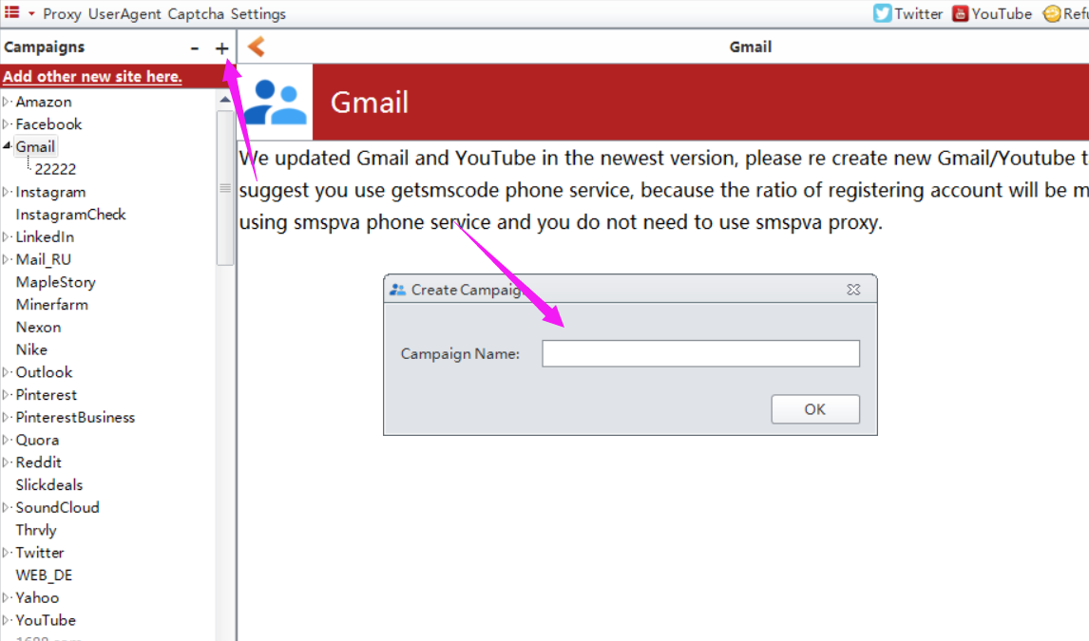

How to enter value for these options?
1. manually input value for them one by one.
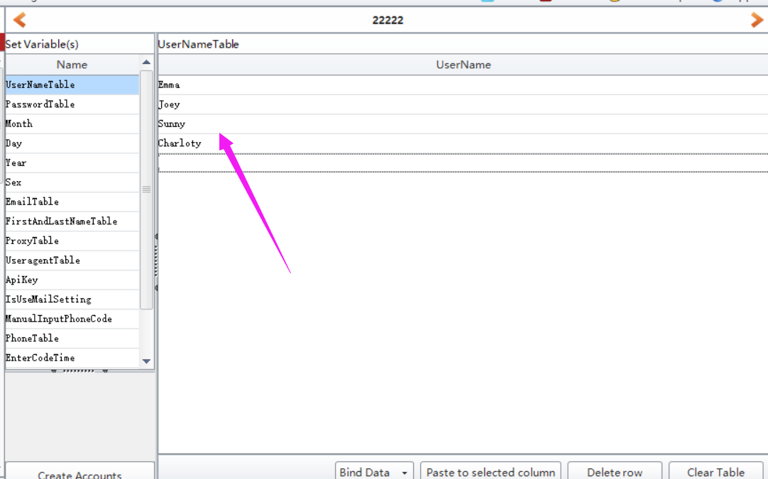
- click “BindData” to choose “Import from file” option to upload multiple data at a time.
Note: please check this column (the checked column color will be yellow) first which you need to multiple upload data.
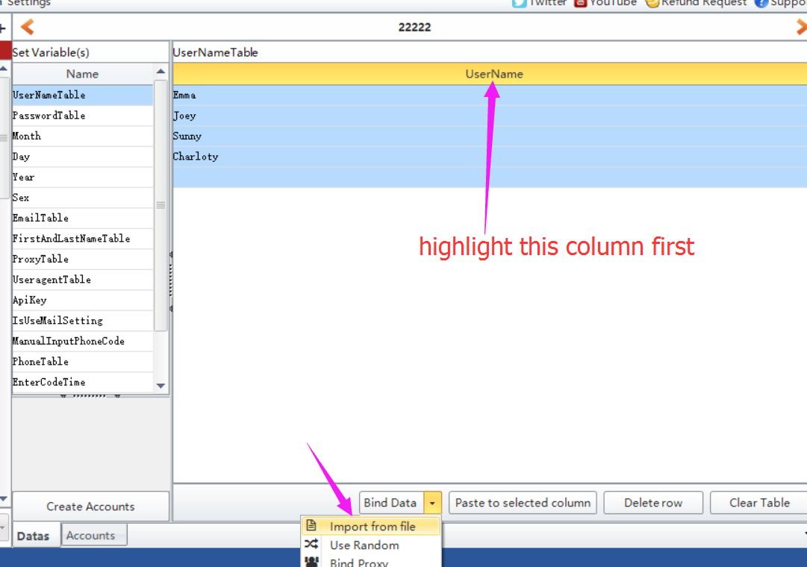
- click “BindData” to choose “Use Random” option to auto generate some data based on the condition you preset.
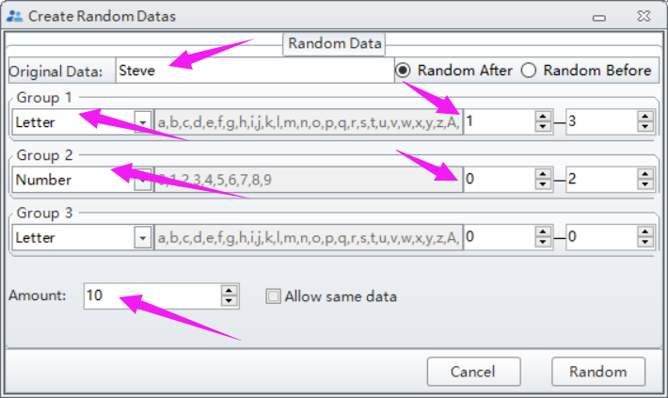
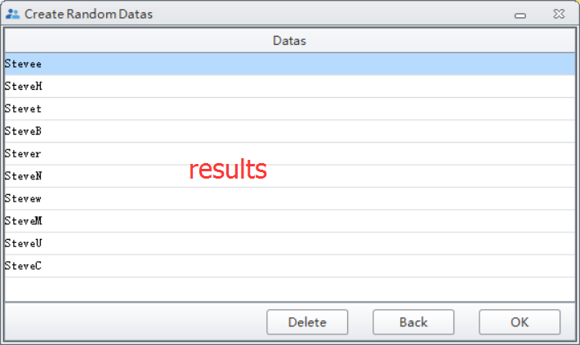

Note: please do not forget to click “Create Account” button to save the data you entered/modified.
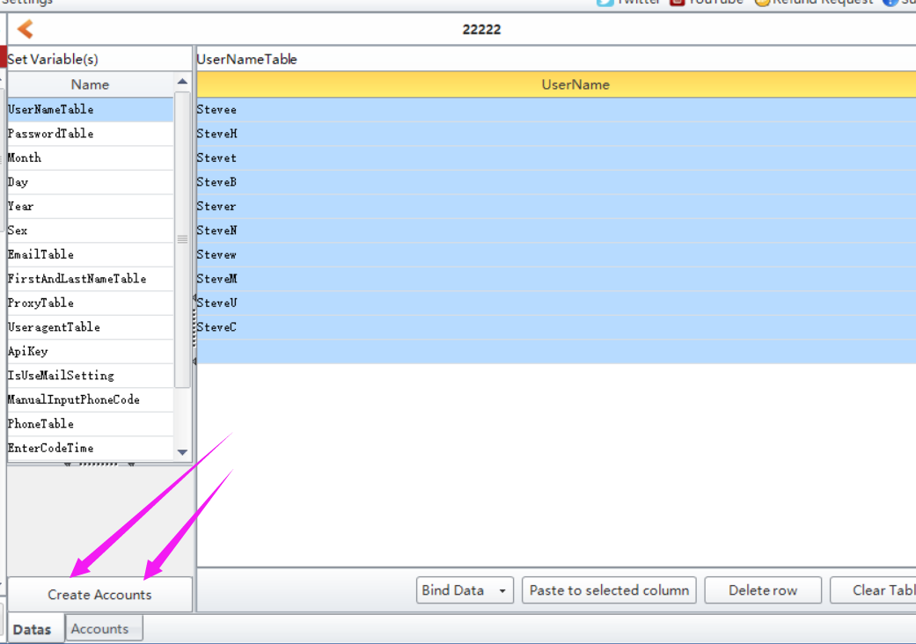

Where to find the data i entered?
Click Accounts button, then you can find all data you entered in this form:

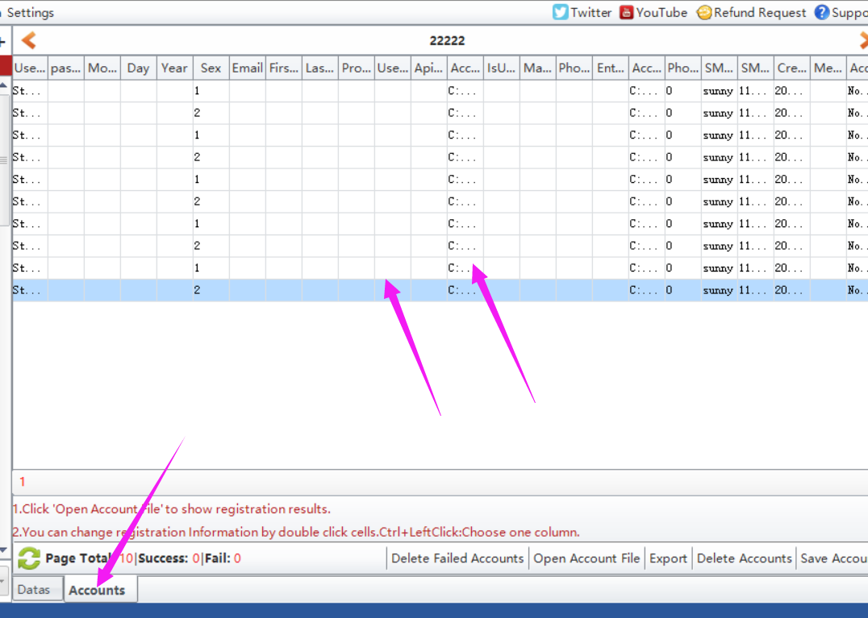

Where to start to run the task?
Click Start button to run.
